ComputerAccessories

Website

Student:

محمد الغزي

حمد العسافي

زياد المطيري

This Project is for our course IT System we used HTML and CSS language

We crate 5 pages HTML first page is Homepage (Project.html) and the other are for accessories ( project2.html, project3.html, project4.html ) and one for information about the website ( about.html ) and we crate one page CSS ( style.css ) for design of 5 pages HTML .

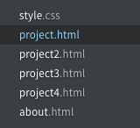

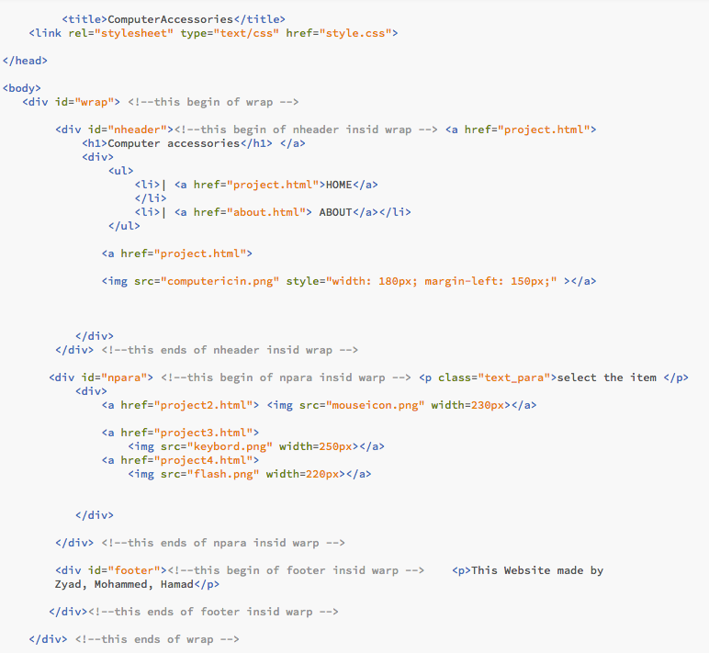

This page is Home page it has < head> contain <title> for name of tab of browser, and there is a<body> contain <div> inside the <body> first <div> we give him ID for CSS page to design it, we name the ID (wrap) and inside the <div> (wrap) we crate three <div> first one we give him id called (nheader) has the same job to design it inside the CSS page the (nheader) is in the top of webpage contain name of website and logo

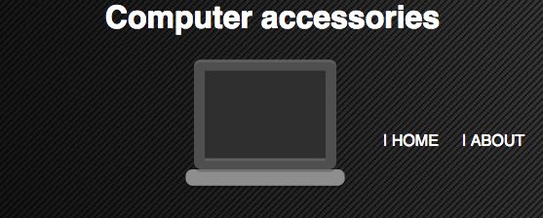

the second <div> we give him id called (npara) has the same job to design it inside the CSS page the (npara) is in the middle of webpage contain picture of type of accessories you want search to buy it if you click on images of one of the type of accessories (mouse, keyboard, flash) it well transfer to other webpage (project2.html, project3.html, project4.html) using <a href=”project2.html”> </a> 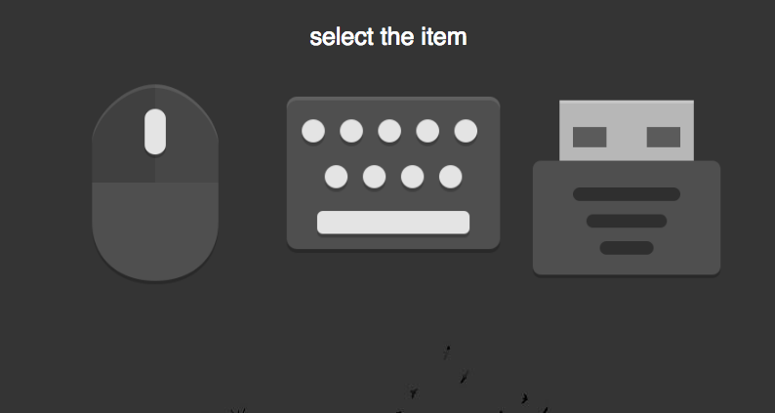

if click on mouse well transfer to (project2.html) it well show you a lot of mouse type

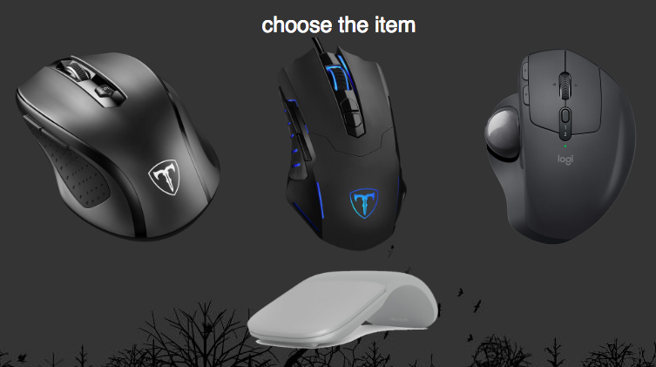

if click of one of these it well transfer to amazon.com to buy it

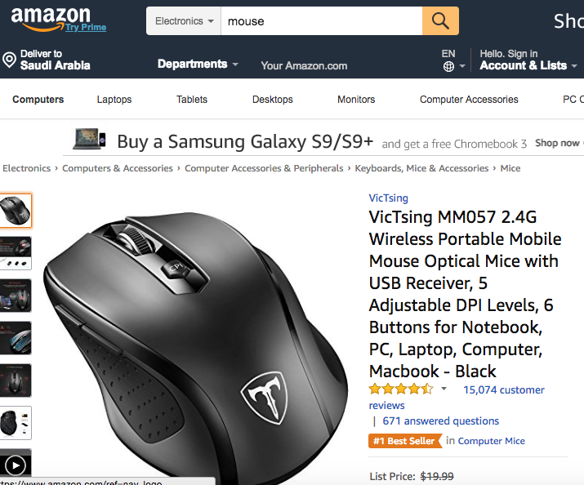

the third <div> we give him id called (footer) has the same job to design it inside the CSS page the (footer) is in the base of webpage contain short text about the website.



The other project 2 and 3&4 and “about page” has the same code only deferent is on <body>

The CSS page contain ID and Class for HTML pages 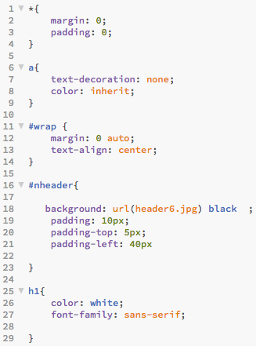

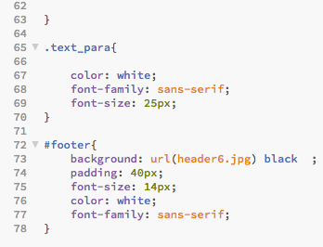

The ID define as ( # ) then the name of <div> like #footer { design }

The class define as ( **.** ) then name of <div> like **.**text_para { design }

The ( * ) is means all design of page

Some word has Reserved words like h1 { design } and a{ design }

This website targets computer users